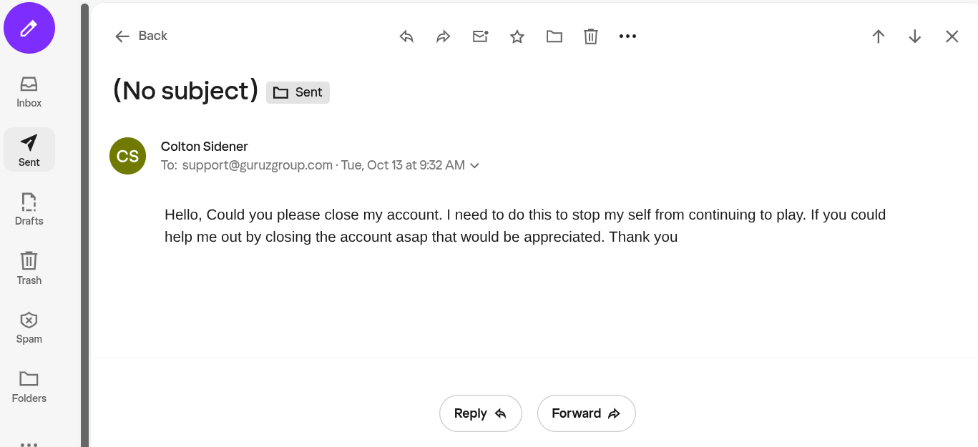
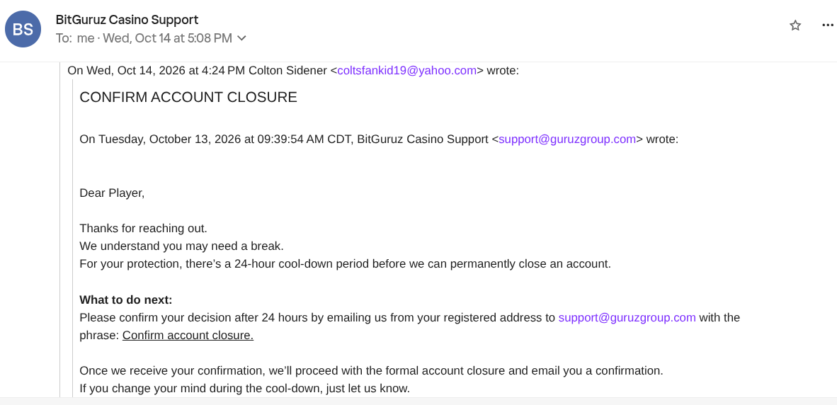
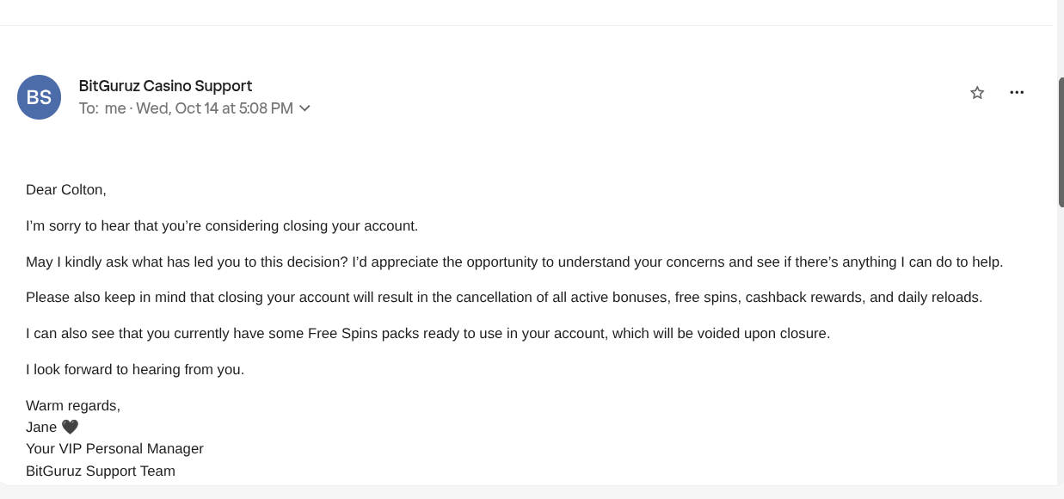




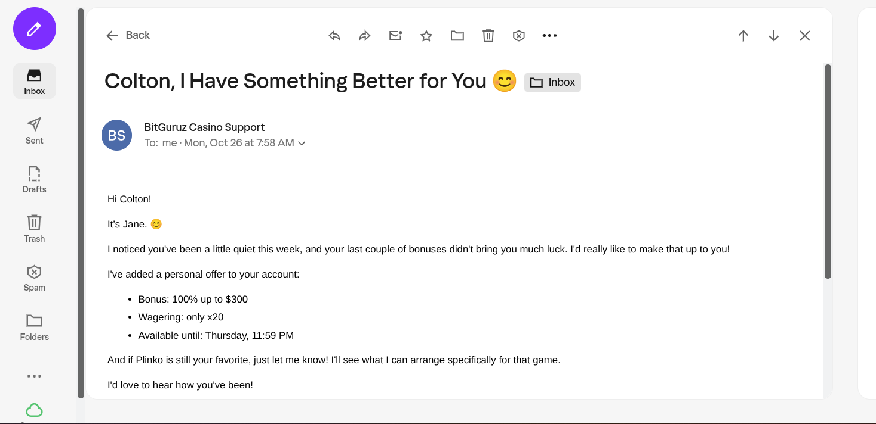

Deposit History
10/28/26:
Receipt Address: 0xa9d1e08c7793af67e9d92fe308d5697fb81d3e43
TXN:0x1f3b2ed731a456f188eb777933be60c5dc63e2e383925e74785fa5351cefa5f9
Amt:0.74490128 ETH ($1,000 USD)
----------------------
Receipt Address: 0xa9d1e08c7793af67e9d92fe308d5697fb81d3e43
TXN:0x7a07994e73b7bd49e9ca594685ac21ed5bc98f7209e828d783ed4edd1a283e54
Amt:0.41102929 ETH ($1,000 USD)
----------------------
10/27/26:
Receipt Address:0xa9d1e08c7793af67e9d92fe308d5697fb81d3e43
TXN:0x0795c2a9378a794e4125a07b7b3580cf22804a91851ffb321625b46e96199823
Amt:0.20337232 ETH ($500 USD)
----------------------
Receipt Address:0xa9d1e08c7793af67e9d92fe308d5697fb81d3e43
TXN:0x0e57a537550b1a14532e8381f6b10c84d0f27e46f36d53fd07c312d01f49a498
Amt:0.20463895 ETH ($500 USD)
----------------------
Receipt Address:0xa9d1e08c7793af67e9d92fe308d5697fb81d3e43
TXN:0xc024f54405a276280321cd893e87922426c9ee9acb2fafee580e4513f726b501
Amt:0.41285351 ETH ($1,000 USD)

